Superstore Sales Analysis Project
Comprehensive Data Analytics Portfolio
Prepared by: Nishu verma
Role: Aspiring Data Analyst
Organization: Primeor Solutions
Date: May 2026

Project Overview
This project involves an end-to-end analysis of Global Superstore sales data, comprising over 51,000 records. By leveraging SQL, Microsoft Excel, and Power BI, the objective is to transform raw transactional data into actionable business intelligence through systematic data cleaning, complex querying, and interactive visualization.

Objectives
The primary goals of this analysis include:

- Sales & Profit Performance: Evaluating overall financial health and trends.
- Product Insights: Identifying top-performing categories and sub-categories.
- Loss Prevention: Detecting loss-making orders to optimize pricing and discounts.
- Trend Analysis: Understanding monthly sales fluctuations and seasonal peaks.
- Geographic Evaluation: Comparing market-wise revenue and regional performance.
- Operational Efficiency: Analyzing shipping modes and their impact on profitability.
- Strategic Visualization: Building high-fidelity, interactive dashboards to support data-driven decision-making.

Dataset Description
The dataset provides a granular view of retail operations including:

Field Category | Key Attributes
Order Details | Order ID, Order Date, Ship Mode
Customer & Geography | Customer Name, Market, Segment
Product Information | Product Name, Category, Sub-Category
Financial Metrics | Sales, Profit, Quantity, Discount

Tools & Technologies
Tool | Purpose
Microsoft Excel | Initial data cleaning, EDA, and preliminary Pivot Table dashboards.
SQL (MySQL) | Advanced querying, CTEs, and Window Functions for business logic.
Power BI | Interactive visualization, DAX measures, and drill-down reporting.

Data Cleaning (Excel)
To ensure data integrity, the following preprocessing steps were executed:

- Deduplication: Removal of duplicate records from the 51K+ dataset.
- Missing Value Handling: Addressing nulls in numerical and categorical fields to prevent skewed analysis.
- Standardization: Correcting inconsistent text values and formatting date columns for temporal analysis.
- Validation: Ensuring data type consistency across all 24 columns.

Excel Dashboard Analysis
A dynamic Excel dashboard was developed to provide an immediate summary of KPIs:

- KPI Cards: Total Sales and Total Profit metrics.
- Visual Analysis: Monthly Sales Trends and Segment-wise performance.
- Interactivity: Slicers for Category and Region to allow for localized insights.

Refer to the attached Excel workbook for the full dashboard. 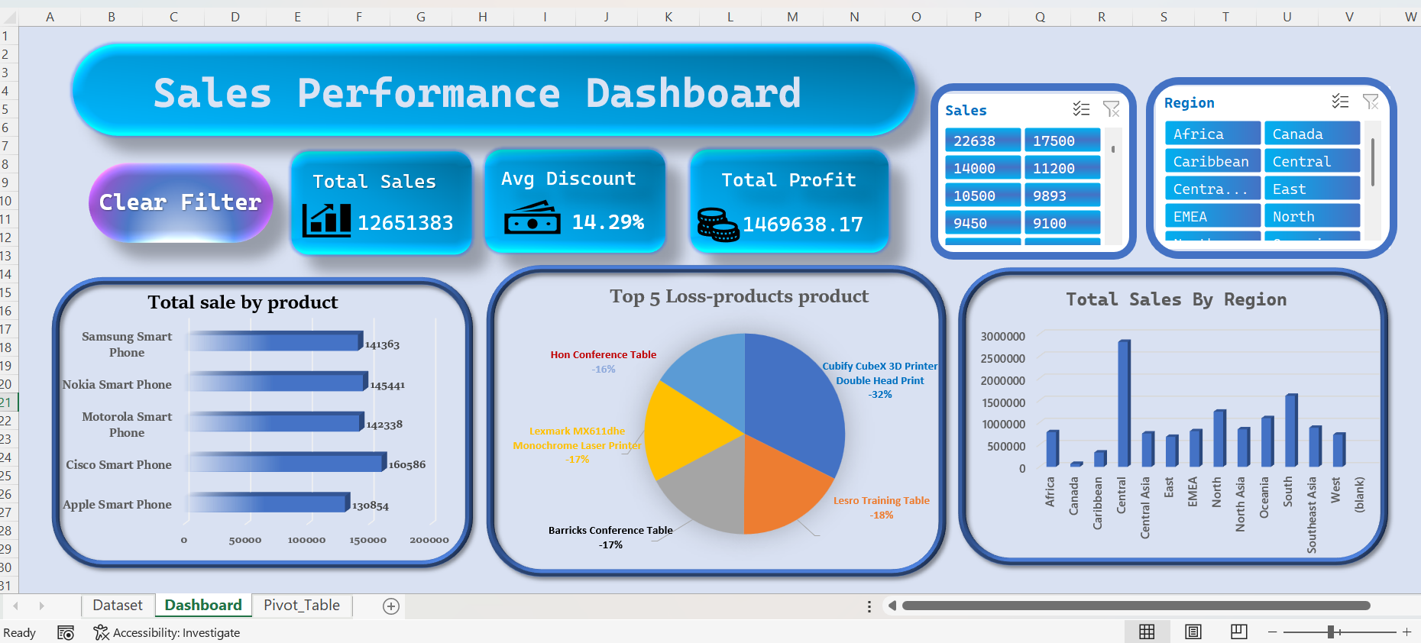

SQL Business Analysis
Complex business questions were addressed using optimized SQL queries:

1. Top 10 Profitable Products
- Objective: Identify the products generating the highest profit concentration.
- Analysis: Highlights that a significant portion of profit is driven by a small subset of the inventory.
- SQL Reference: 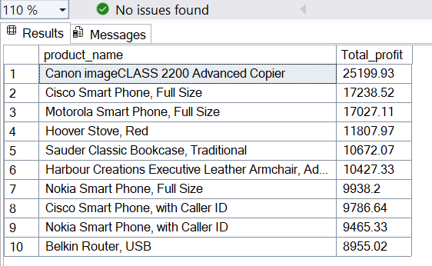

2. Loss-Making Orders
- Objective: Identify orders with negative profit to review discount strategies.
- Insight: Highlights specific sub-categories requiring immediate pricing optimization.

3. Temporal Sales Trends
- Objective: Analyze month-wise sales to identify seasonality.
- Insight: Identifies peaks that assist in inventory planning and demand forecasting.

4. Market-wise Revenue Analysis
- Objective: Compare revenue distribution across global markets.
- Insight: Certain markets contribute disproportionately to total revenue, indicating growth opportunities.

Power BI Dashboard
The multi-page Power BI dashboard offers a 360-degree view of business performance, featuring:

- Executive Overview: High-level KPIs for Sales, Profit, and Order Volume.
- Market Analysis: Interactive maps showing regional performance.
- Customer Insights: Top customer identification and segment analysis.
- Advanced Features: Integrated "Clear All Filters" button and bookmarks for enhanced UX.

Key Business Insights
- Profitability Concentration: Profit is heavily skewed toward top-performing products; inventory should prioritize these items.
- Pricing Strategy: Negative profit orders indicate a need to re-evaluate discount thresholds in underperforming regions.
- Seasonal Demand: Clear fluctuations suggest that marketing spend should be aligned with historical high-volume months.
- Regional Growth: High-performing markets present targeted expansion opportunities to maximize ROI.

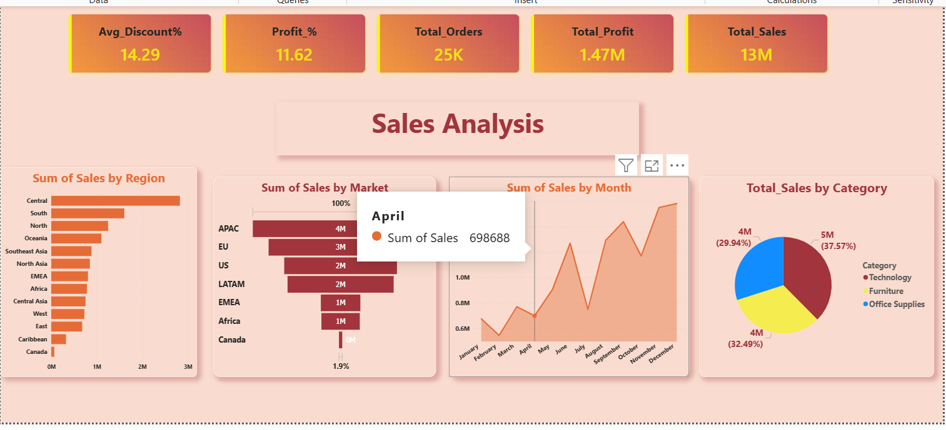
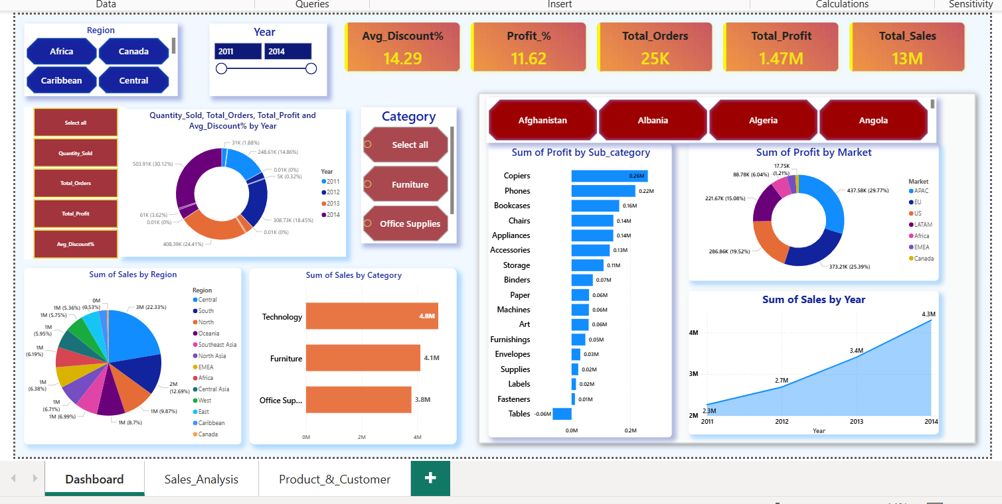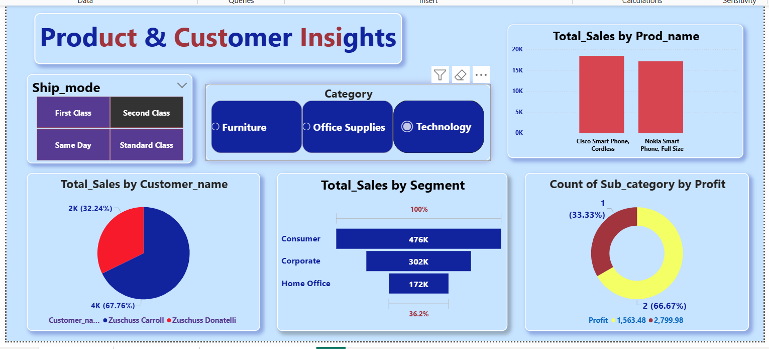

Conclusion
This project demonstrates a comprehensive approach to data analytics, moving from raw data cleaning to complex querying and high-fidelity visualization. The resulting insights provide a roadmap for improving sales performance, optimizing shipping efficiency, and maximizing profitability across the Global Superstore ecosystem.

Future Improvements
- Predictive Analytics: Developing sales forecasting models using historical trends.
- Advanced Segmentation: Implementing RFM (Recency, Frequency, Monetary) analysis for customer loyalty.
- Automation: Scheduling automated data refreshes via Power BI Service.
- Live Reporting: Integrating SQL Server with Power BI for real-time reporting.

